My Little Book of

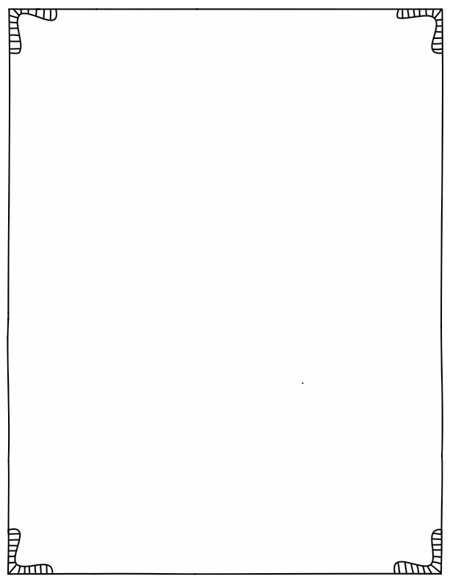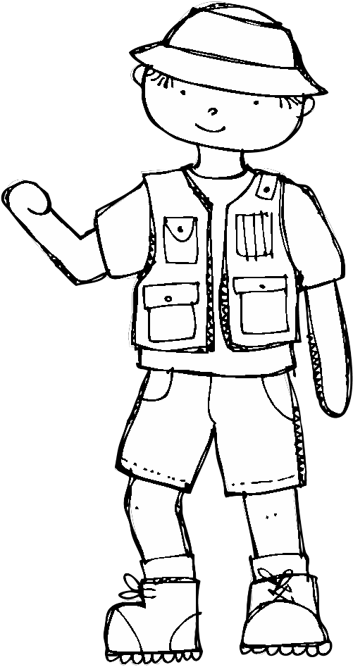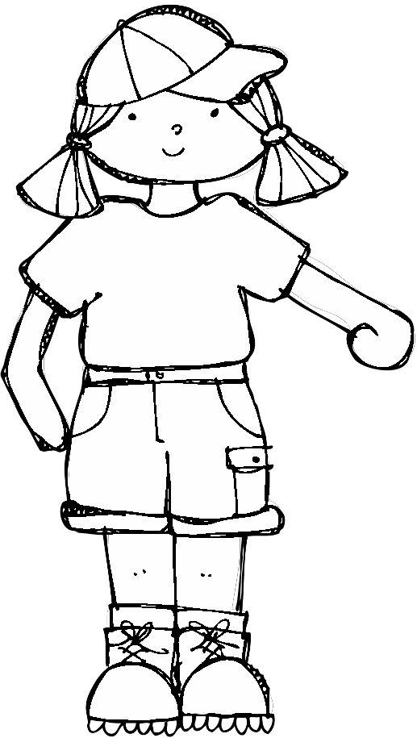

Story Problems!

By:

My Little Book of

Story Problems!

By:

John and Parker each ate 6 s’mores.

Then, they each had 4 more! How many s’mores did they have in all?

John and Parker each ate 6 s’mores.

Then, they each had 4 more! How many s’mores did they have in all?

Show your work:

Show your work:

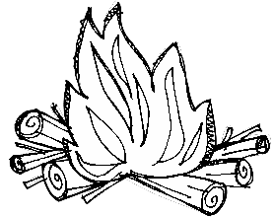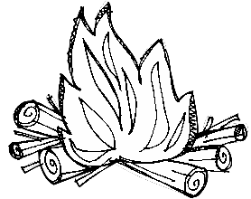

Show the number sentence: Show the number sentence:

Jeff got to the campsite at 4pm. It took him an hour to build his tent and then 2 more hours to catch a fish for dinner. What time was it when he finally sat down with his dinner?

Jeff got to the campsite at 4pm. It took him an hour to build his tent and then 2 more hours to catch a fish for dinner. What time was it when he finally sat down with his dinner?

Show your work:

Show your work:

Show the time on the clock:



Show the time on the clock:

Haley caught 4 snapper fish, 7 tuna fish, and 16 hermit crabs. Did Haley catch more fish or crabs? How many more?

Haley caught 4 snapper fish, 7 tuna fish, and 16 hermit crabs. Did Haley catch more fish or crabs? How many more?

Show your work:

Show your work:



Show the number sentence: Show the number sentence:

My friend and I went camping. We started with a bag of 19 marshmallows. Then, we each made 6 s’mores. How many marshmallows were left in the bag?

My friend and I went camping. We started with a bag of 19 marshmallows. Then, we each made 6 s’mores. How many marshmallows were left in the bag?

Show your work:

Show your work:



Show the number sentence: Show the number sentence:

Genesis went camping and brought 5 rain coats, 4 long sleeved shirts, and 6 tank tops. What fraction of her clothing were rain coats?

Genesis went camping and brought 5 rain coats, 4 long sleeved shirts, and 6 tank tops. What fraction of her clothing were rain coats?

Show your work:

Show your work:



Show the number sentence: Show the number sentence:

Polly woke up at 7:30am. It took her 2 hours to eat breakfast, shower, and get ready for the day. What time was it when she was ready?

Polly woke up at 7:30am. It took her 2 hours to eat breakfast, shower, and get ready for the day. What time was it when she was ready?

Show your work:



Show the time on the clock:

Show your work:

Show the time on the clock:

The campsite was filled with families! There were 9 little girls, 16 little boys, 7 moms and 9 dads. How many people were there altogether?

The campsite was filled with families! There were 9 little girls, 16 little boys, 7 moms and 9 dads. How many people were there altogether?

Show your work:

Show your work:



Show the number sentence: Show the number sentence:

My Little Book of

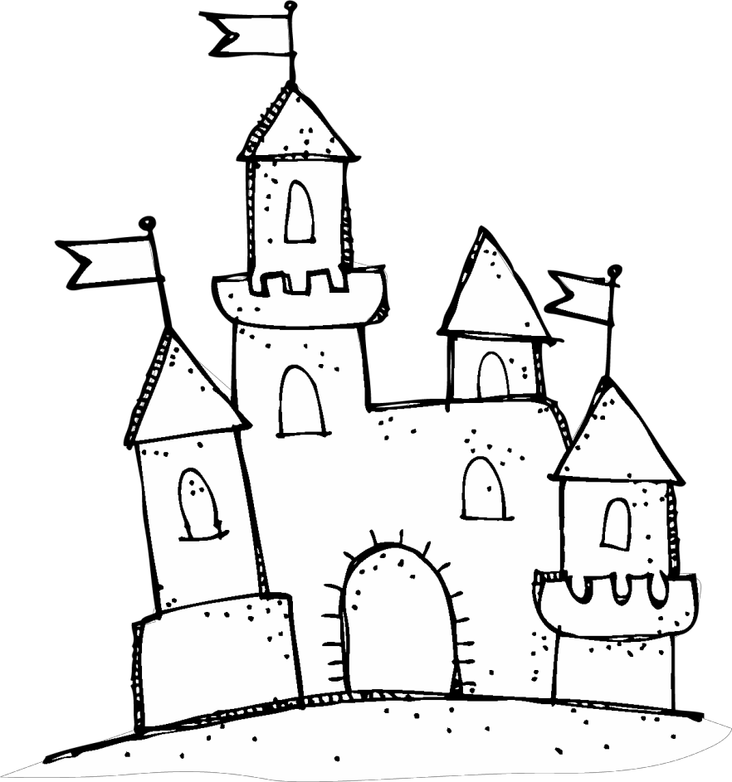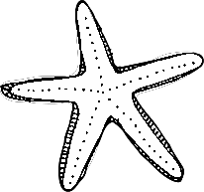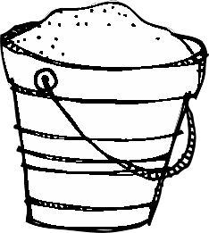

Story Problems!

By:

My Little Book of

Story Problems!

By:

Halle brought 11 popsicles to the beach.

She went swimming and went she returned 4 of the popsicles had melted! How many were left?

Halle brought 11 popsicles to the beach.

She went swimming and went she returned 4 of the popsicles had melted! How many were left?

Show your work:

Show your work:

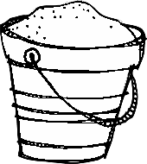

Show the number sentence: Show the number sentence:

18 kids were swimming in the pool. 9 got out to dry off. How many were still swimming in the pool?

18 kids were swimming in the pool. 9 got out to dry off. How many were still swimming in the pool?

Show your work:

Show your work:



Show the number sentence: Show the number sentence:

My mom and I got to the beach at 4pm. We stayed for 2 and a half hours. What time did we leave?

My mom and I got to the beach at 4pm. We stayed for 2 and a half hours. What time did we leave?

Show your work:



Draw the time on the clock:

Show your work:

Draw the time on the clock:

70 first graders waited in line for the roller coaster. 20 students went on the roller coaster. How many students were still in line?

70 first graders waited in line for the roller coaster. 20 students went on the roller coaster. How many students were still in line?

Show your work:

Show your work:



Show the number sentence: Show the number sentence:

Tristan received 3 boxes of candy.

Each box had 12 pieces of candy in it.

How much candy did he get in all?

Tristan received 3 boxes of candy.

Each box had 12 pieces of candy in it.

How much candy did he get in all?

Show your work:

Show your work:



Show the number sentence: Show the number sentence:

Jose had built a sandcastle that was 7 feet tall. Hank built a sandcastle that was 4 feet tall. Who built the taller sandcastle? How much taller was it?

Jose had built a sandcastle that was 7 feet tall. Hank built a sandcastle that was 4 feet tall. Who built the taller sandcastle? How much taller was it?

Show your work:

Show your work:



Show the number sentence: Show the number sentence:

Sally collected 64 white seashells and

31 blue seashells. How many seashells

did she collect in all?

Sally collected 64 white seashells and

31 blue seashells. How many seashells did she collect in all?

Show your work:

Show your work:



Show the number sentence: Show the number sentence: